PRACTICE TEACHING PE IN ENGLISH
PART 1 - GIVING INSTRUCTIONS TO MOVE YOUR BODY
1° Match the English to the French
Walk (run, jump) sideways  Skip along  Jump along  Hop on one foot  Take baby steps  Take big strides  Run in a straight line  Run in a zigzag  Go forwards  Go backwards  Walk/run uphill  Walk/run downhill  On your tiptoes  Crawl under |  | - à pas chassés  - à pas de fourmis  - en courant / en marchant en avant  - en descendant / en descente  - courir en slalom  - ramper sous  - en sautillant  - courir droit  - sur la pointe des pieds  - à grand pas/ à pas de géants  - à cloche pied  - en courant / en marchant en arrière  - en sautant  - en montant / en montée

2° Do you know the meaning of all the instructions?
Stand up Sit down
Squat down Squat / Do a squat
Kneel down Bend your knees (slightly)
Turn around Turn back
Twist your spine Take a step
Stretch your arms out in front of you / behind you / above your head
Stretch Lie down
Bend your arms Fold your arms
Bend forward to touch your toes Raise your knees / Do a knee raise
Jog on the spot Do lunges
Tilt your head

⚠️ There are two major FRANGLAIS expressions to absolutely avoid!
- At the beginning of the session: “Warm up your articulations _________________________”
- Do this exercise to improve your core strength: “Do ________________________________”
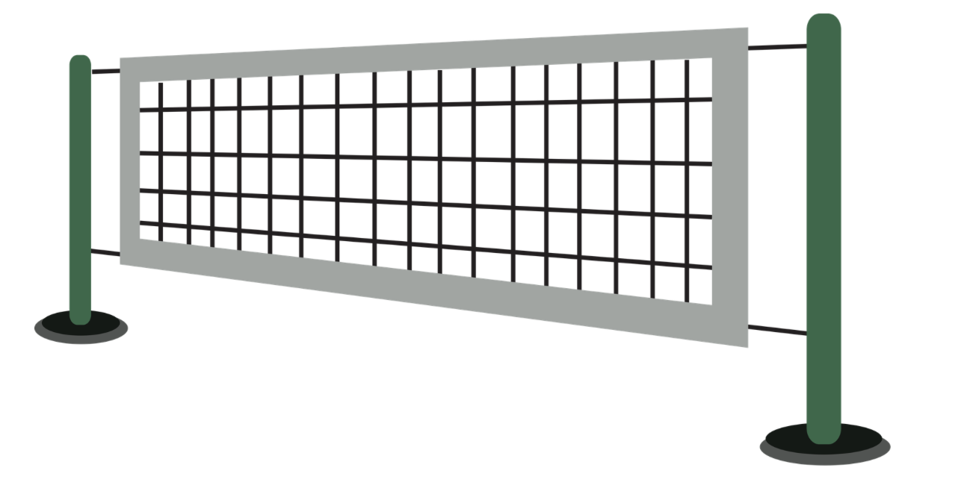


PART 2 - NAMING THE PE EQUIPMENTS DURING THE LESSON
________________________________________________________________________________________________

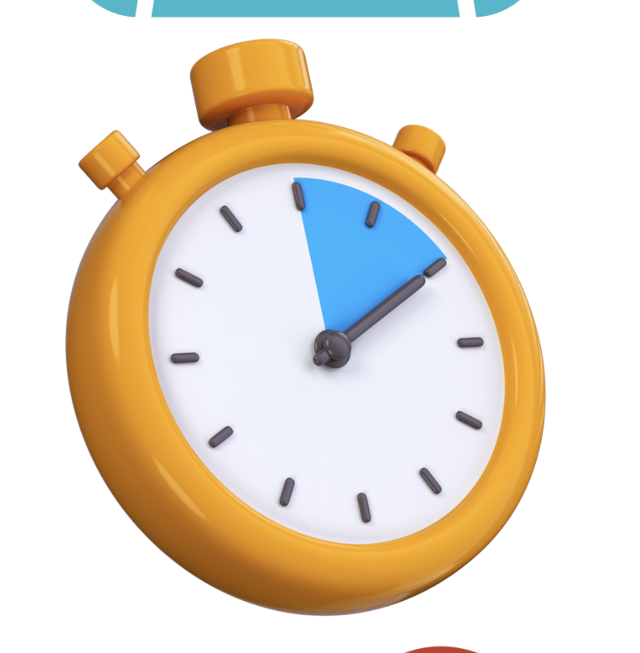
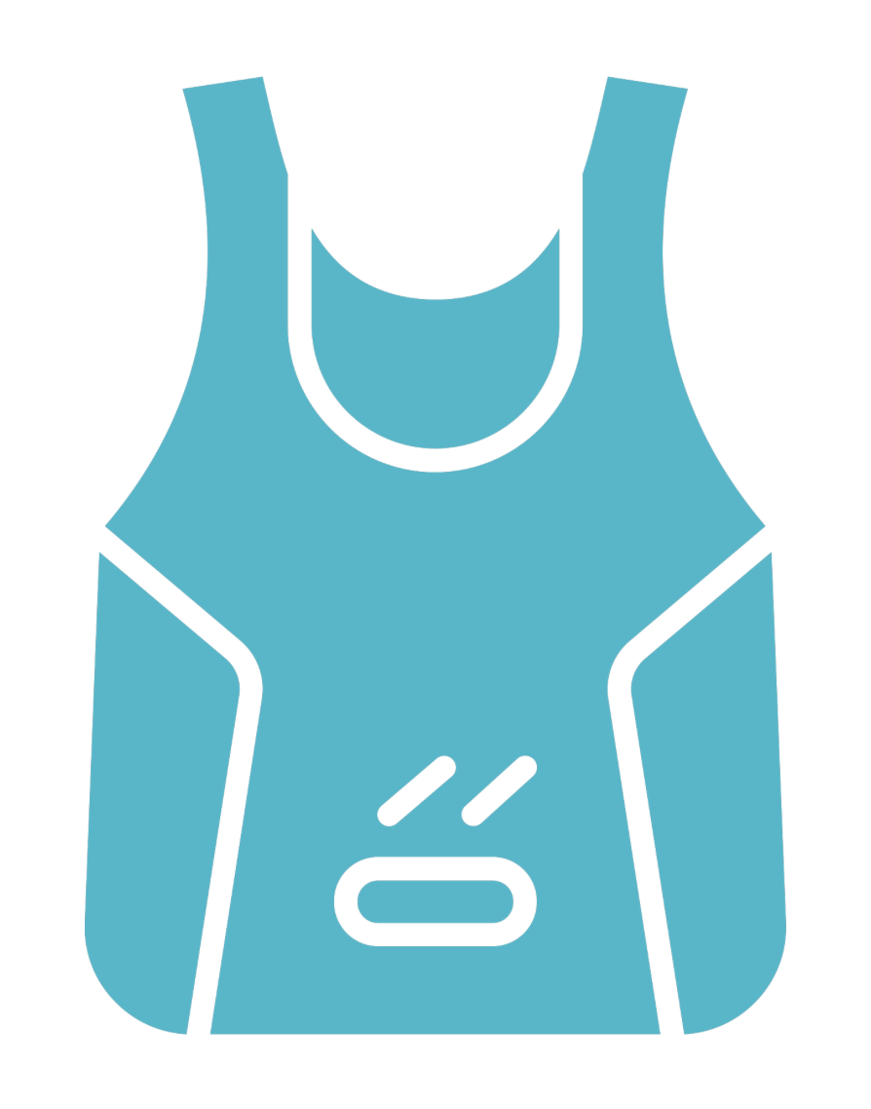
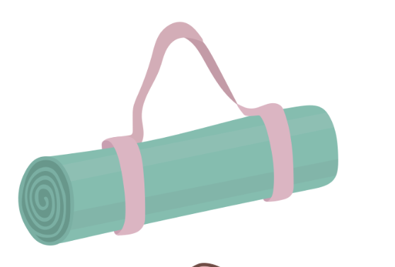

________________________________________________________________________________________________

PART 3 - CREATE AN ACTIVITY
In your groups, create a 5min sport activity of your choice to do with the class (as your pupils). BE CREATIVE!

The activity must be in English and the rest of the class – the pupils – must participate in English. This activity must be interactive.
Your activity must be something that does not any require equipments.

Before you start the activity, tell us:
- Are we in middle school / high school? Which grade?
- Are we at the beginning, middle or end of the school year?
- Where does your activity fit into you PE ‘’séquence’’ and ‘’séance’’?

You can do:
- A joints warmup (use correct body vocab and verbs: rotate, tilt, lean, bend…)
- A crossfit warmup (use correct names of exercises: squats, lunges, the plank…)

- Animal walks (create a cardio warmup, use correct terms for animals and their walks)
- A breathing exercise to cooldown (https://www.youtube.com/watch?v=VDhJVA6QoAU)
- Yoga stretching (without mats: be able to give precise instructions to do a few movements)
- a quick PHYSICAL ACTIVITY:
  - Parkour Skills (teach us 1 skill for beginners (6e) as an introduction, include the social skill of cooperation in your activity)
  - Dance or Step (teach us a mini-choreography or block, use precise terms for dance moves or step movements, be able to describe what you want us to do in English with clear instructions)
- Any other activity

