**L1 TD1 WARMUP VOCABULARY**

Here is the vocabulary you will hear during the warmup.

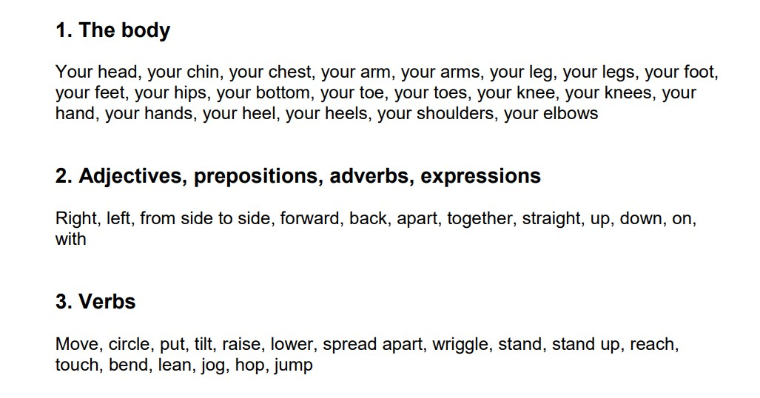

Source: https://blogacabdx.ac-bordeaux.fr/espacelangue24/warm-up-pe-lesson/